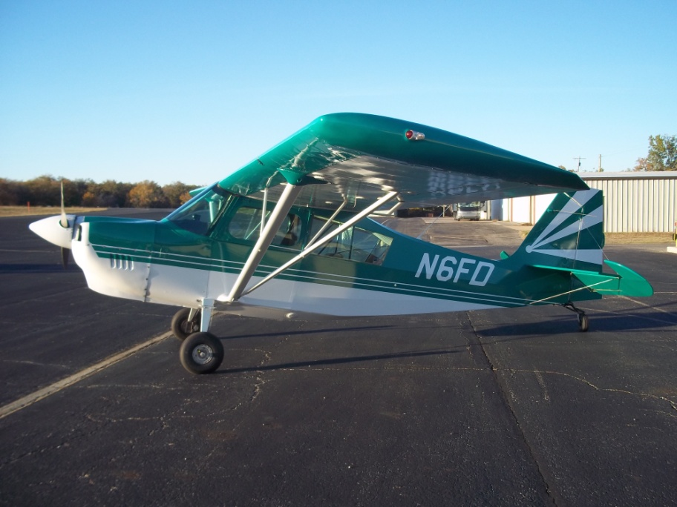
1991 American Champion Super Decathlon 8KCAB

- TTAF 1275
- TTE 1275 SNEW Lycoming AEIO-360-H1A 180HP
- Prop 330 SOH Hartzell HC-C2YR
- Metal Spars
- Inverted Fuel/Oil
- Empty Weight 1303
- All Logs, Maintenance Manuals, Parts Catalog
- All AD’s Complied
- Always Hangared
- Fresh Annual-Due 10/2013
- Went Back to Factory in 2009 for Updates
- Exterior 8/10
- Interior 8/10

Fantastic example of a new generation Super-D. Paint and Interior are in great condition. Only light acro. Wheel pants included (not pictured). Went to American Champion factory in 2009 for a ton of updates and improvements.

Contact: Jordan at Sky King Aviation Services 580-504-2292 $78,900

